Travelogix

Facebook Integration

Document Identification

|  |  |  |  |
| --- | --- | --- | --- |
| Author | | Document Location (repository/path/name) | |
| Deekshitha A.R | | JAM Project Collaboration Site | |
| Version | Status | Date (YYYY-MM-DD) | Document Classification |
| 1.0 | Initial | 2016-07-26 | Internal |

Revision history

|  |  |  |
| --- | --- | --- |
| Version | Date | Description |
| 1.0 | July 26 2016 | 1st Release of the document |
|  |  |  |

approvals/Sign-off

|  |  |  |  |
| --- | --- | --- | --- |
| Date | SME / Function | Sections in this document | Topics/Section |
|  |  |  |  |
|  |  |  |  |

Reference documents

|  |  |  |
| --- | --- | --- |
| Topic | Owner | Storage Location / Link |
|  |  |  |
|  |  |  |
|  |  |  |

Document Review

|  |  |  |  |
| --- | --- | --- | --- |
| Date | Owner | Reviewer | Comments |
| 26/07/2016 | Deekshitha A.R | Sanu |  |
|  |  |  |  |

Contents

Travelogix 1

Document Identification 1

approvals/Sign-off 2

1. About this Document 4

2. Implementation 4

3. Acronyms 7

## 

## About this Document

This document outlines the integration of [y]-commerce with facebook for logging into the website using the facebook credentials.

## Implementation

Sendind the request to the facebook and getting the token.

* Authenticating the token
* logging in into the hybris system using the token and the resultant profile information from Facebook.

Sending the request using the “FacebookTokenGenerator” and getting the token in response and the application ids, secret id and url are given in this class.

* **Authenticating the token** :

. Athenticating the tiken by using the getFBGraphUrl() method of FacebookTokenGenerator

* **Logging into Hybris system**:

If the token is valid using the “FacebookAutoLoginStrategy” using the token and resultant Profile can looking into the hybis system.

**Facebook Login Implementation**

The return response from the facebook authenticates again while login and uses FacebookAutoLoginStrategy , FacebookAuthenticationToken, BruteForceAttackCounter.

**Steps to integrate Facebook into the website**

1. Give the url ${fburl} which is defined in home page controller for facebook button in sing in pop up.
2. Add the facebook addon and run ant install
3. Proceed with the login using facebook from ui

On hover u can see the url

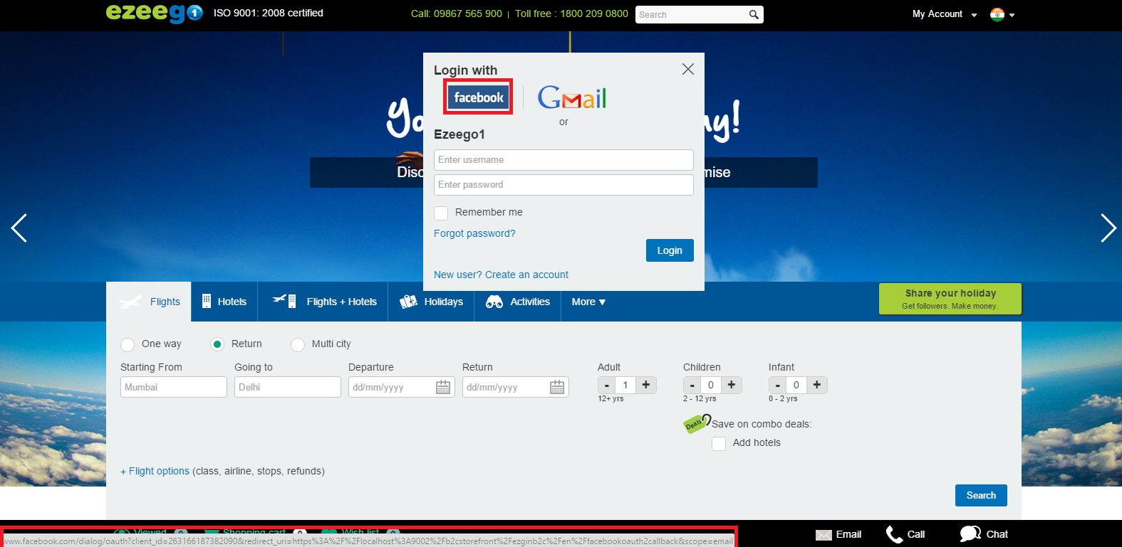

On click it will take you to the facebook account and give the ui to login if you not logged in.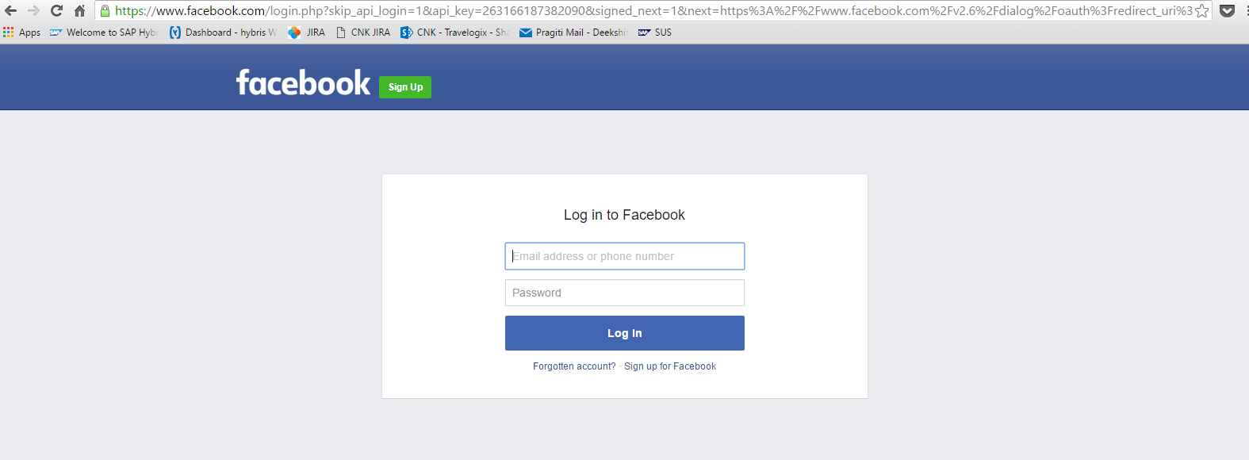

On login it takes you back to the web site and log you in with the facebook credentials